**Campaign Management**

--> From Customer Database Send Automated Mails, SMS to Customers.

--> Set Automated Marketing Campaigns to keep your Contacts engaged with regular messages.

**Campaign Management Steps**

--> After Register as a client, if they won’t move to lead, sends a mail like offer only this week

--> Send Social Media Page Links to Clients to follow latest offers

--> Based on Country, Annual Income, Occupation and Age sends a different package schemes

--> Send Quotation Link after successful Registration

--> Client Referred a New Person, based on that information sends a website link to that person

--> If Client Register as a Family Group - Sends Family Travel Offer.

Through Google Analytics Tool We Can Monitor,

**Ticketing System**

--> Ticketing system is looks like a customer care

--> Customer give one complaint- reply for that complaint

--> After registers a ticket- It goes to open Stage

--> If that opened ticket as solved then the ticket goes to closed ticket

**Odoo**

--> Simplify the Quote and Policy

--> Asking for Quote Automatically Calculate Policy Value

--> Then this Policy goes to Pending status, Policy value is reduced in Creation block and Policy value Added in Pending Status

--> Then in policy Completion process Policy Value is added finally, Calculate Total Policy Value

--> Send this policy Page to customer as a mail

**Step 1:**

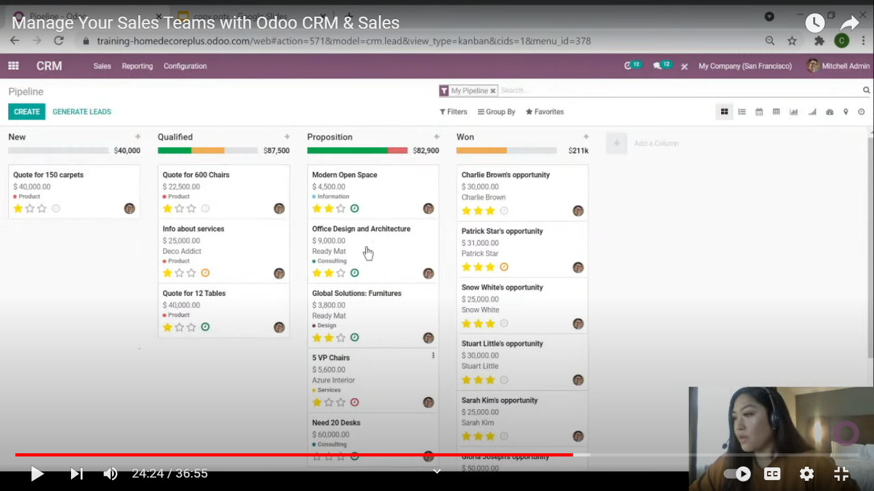

**Step 2:**

